What is Green Screen?
My PBL (Project-Based Learning) is Green Screen. Green screen is a green background in front of which moving subjects are filmed and which allows a separately filmed background to be added to the final image; "A blue-screen effect". The green screen can be digitally removed from the shot and replaced with a different background.

The computer removes the green screen by keying in on the specific color and removing everything of that color from the shot. I believe green is chosen as the default color because human skin usually has no matching green pigments that will be accidentally removed along with the background during green-screening.

Footage 1 | Footage 2 | Footage 3 | Final
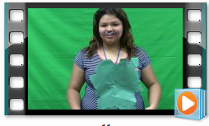 |  | 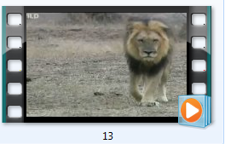
Footage 1 | Footage 2 |  | Final
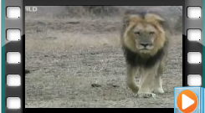 | 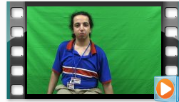 |  | 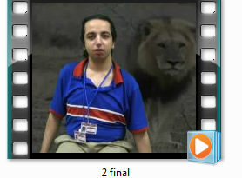
Footage 1 | Footage 2 | Footage 3 | Final
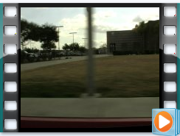 |  |  | 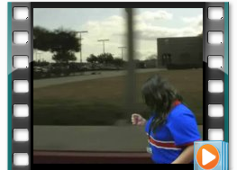

My Web | My Video

